**CLIFFORD CONTROLS**

**PRIMARY CONTROLLER**

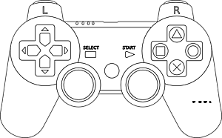

Shift Low

Shift High

Deploy Collector

Runs Collector in Reverse

(When Held)

Stops Collector

Turns on Collector

Retract Collector

**Left-Stick**

Up/Down- Left Drive

**Right-Stick**

Up/Down- Right Drive

**SECONDARY CONTROLLER**



FIRE!

Resets Catapult